**DevOps**

**Day 2**

**Date:** 18.03.2025

**Topics Covered:** Installation of Ubuntu WSL, Jenkins, Docker in Ubuntu and Master slave nodes

**Jenkins**

**Installing Jenkins, Docker and pulling a git project and pushing to Docker Hub**

* Pushing a new Jenkinsfile to GitHub
* Pushing an image to Docker Hub with the Jenkinsfile from GitHub

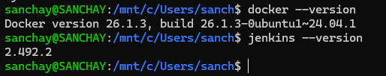

Installations in Ubuntu

**Commands:**

Jenkinsfile in War project

pipeline {

agent any

tools {maven 'mvn'}

stages {

stage('scm') {

steps {

git 'https://github.com/Sanchay1054/WarProject.git'

}

}

stage('build') {

steps {

sh "mvn clean"

sh "mvn install"

}

}

stage('build to images') {

steps {

script{

sh 'docker build -t sanchaym/simplewebapp .'

}

}

}

stage('push to hub') {

steps {

script{

withDockerRegistry(credentialsId: 'Docker', url: 'https://index.docker.io/v1/') {

sh 'docker push sanchaym/simplewebapp'

}

}

}

}

}

}

Creating Jenkinsfile and pushing it to GitHub

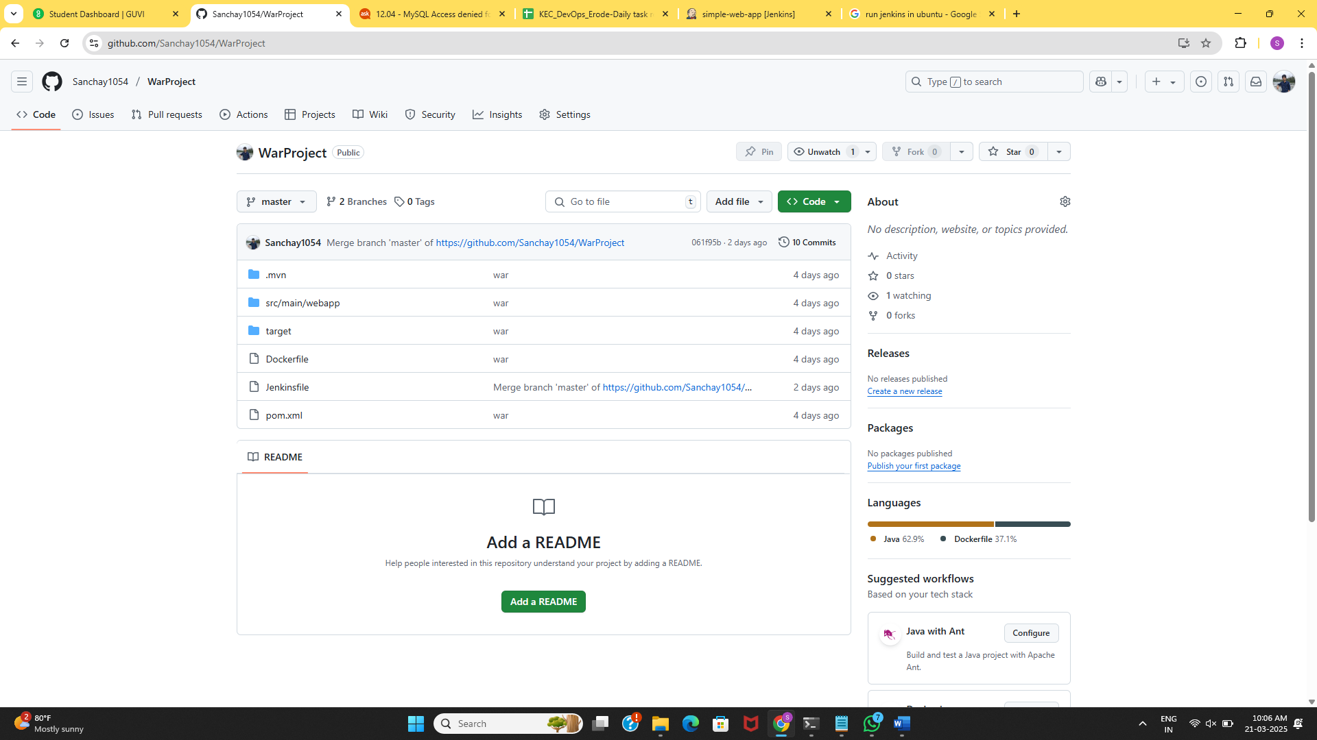

[GitHub](https://github.com/Sanchay1054/WarProject) war project Repository

Adding the GitHub link to the Jenkins

* Pulling the Jenkinsfile
* Running the Jenkinsfile from Jenkins
* Pushing the image to DockerHub

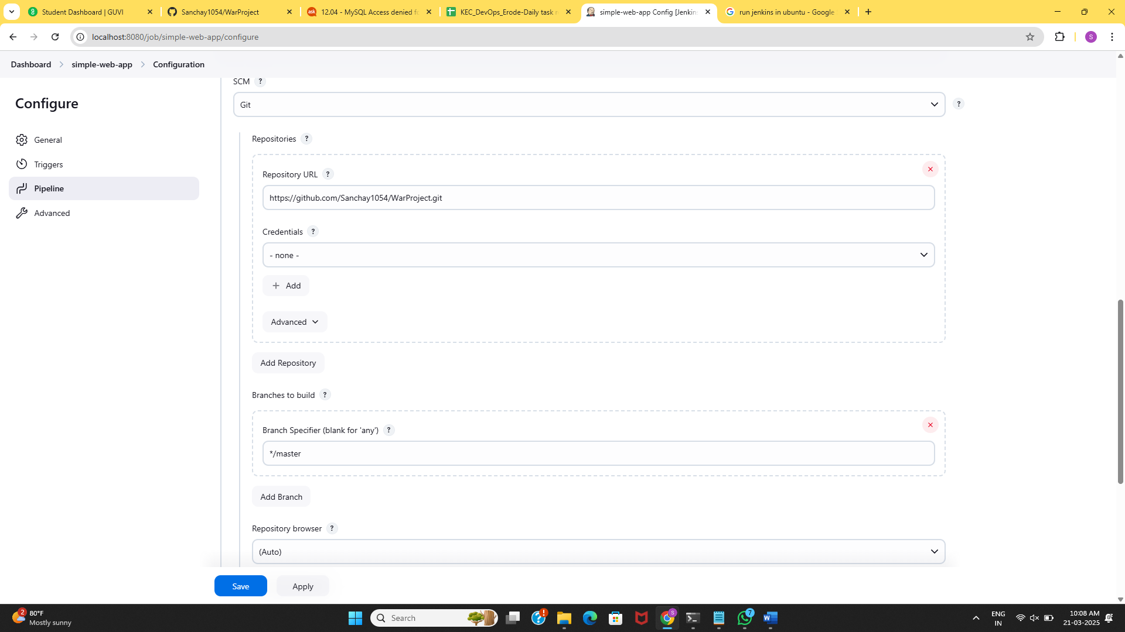

Adding GitHub to Jenkins

Script from Jenkinsfile

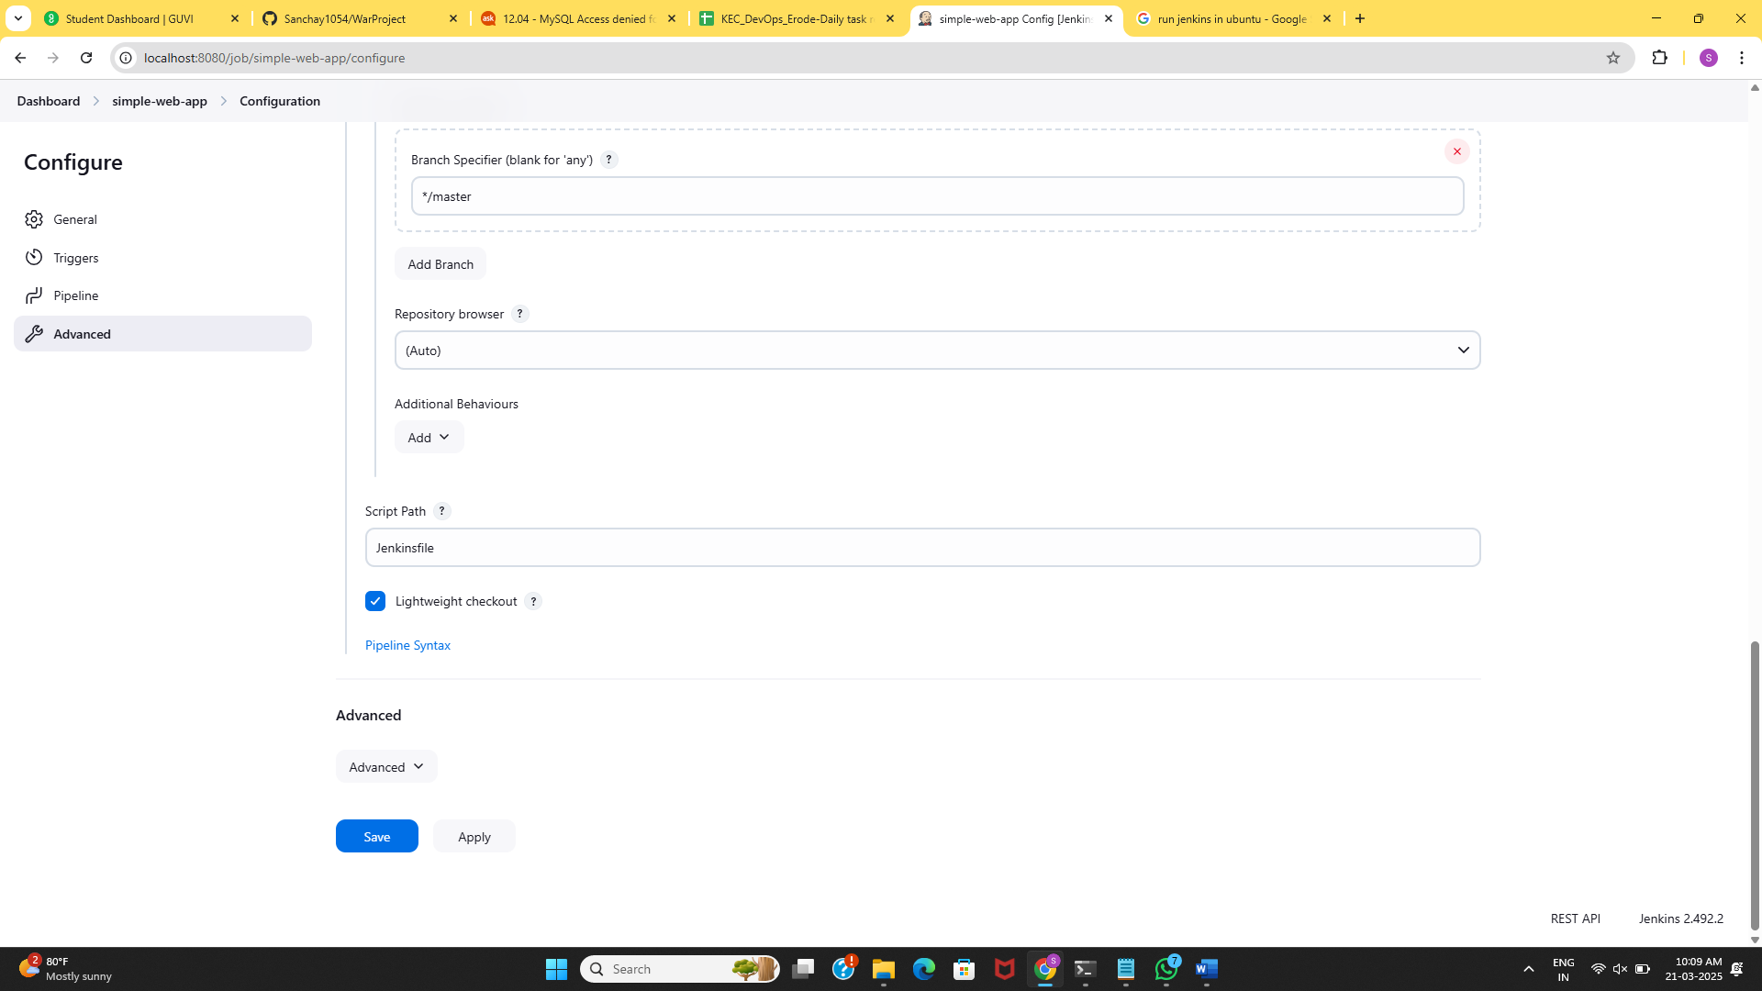

Added Jenkinsfile to execute

**Output:**

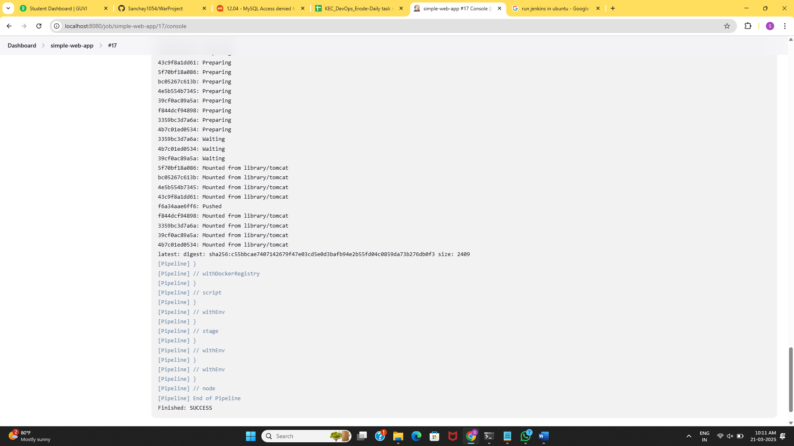

Pushed to Docker Hub from Jenkins

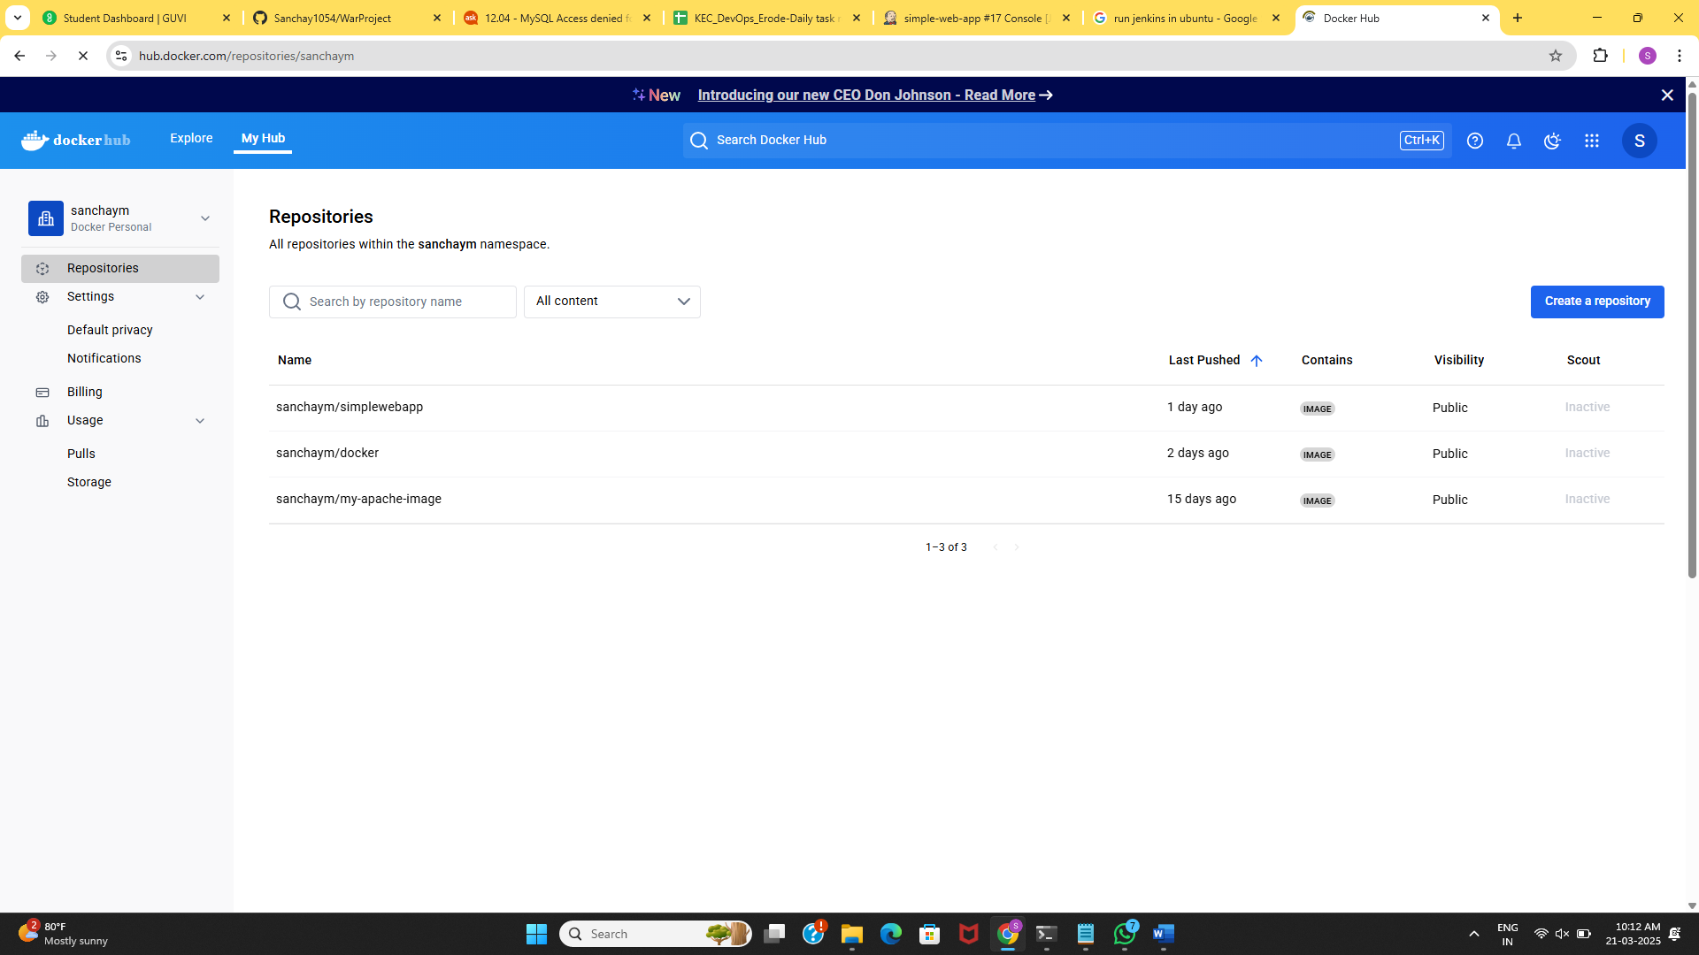War project Image pushed to Docker Hub